**PRACTICAL 2**

**INSURANCE FRAUD DETECTION AND PREDICTION USING VARIOUS MACHINE LEARNING ALGORITHMS AND NEO4J VISUALIZATION**

* **LOGISTIC REGRESSION**
* **DECISION TREE**
* **RANDOM FOREST**
* **GRADIENT BOOSTING**

**[A] DOWNLOAD DATASET**

Download the dataset from kaggle

<https://www.kaggle.com/datasets/arpan129/insurance-fraud-detection>

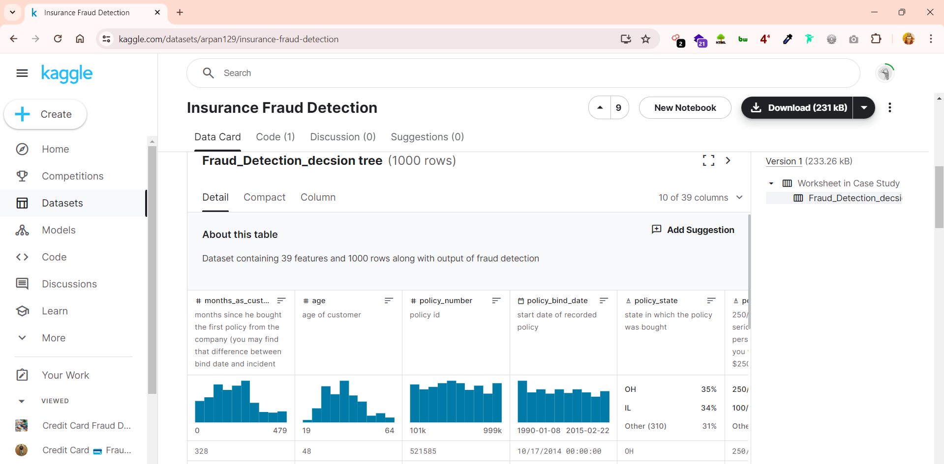

**[B] IMPLEMENTING ML ALGORITHMS FOR PREDICTIONS**

Upload the csv file into colab files and copy its path clicking on **:**

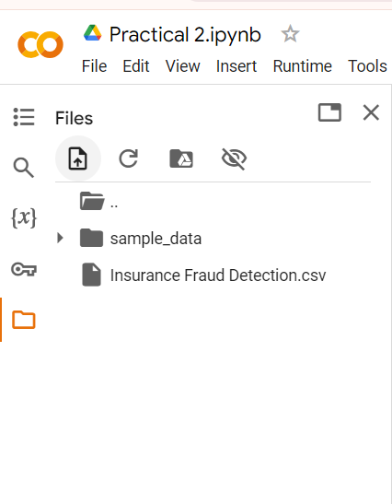

**Data Preprocessing**

* Install packages:

!pip install pandas

!pip install numpy

!pip install scikit-learn

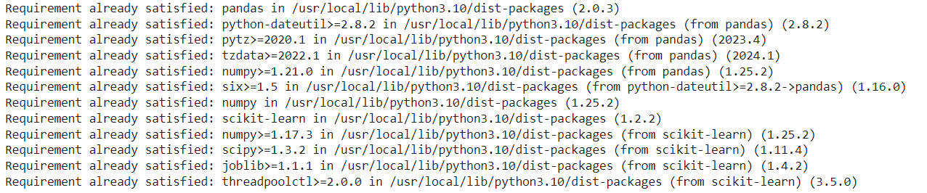

* Load the dataset and libraries:

import pandas as pd

import numpy as np

from sklearn.model_selection import train_test_split

from sklearn.preprocessing import LabelEncoder

# Load the dataset

data = pd.read_csv('/content/Insurance Fraud Detection.csv')

# Display the first few rows of the dataset

print(data.head())

# Copy the original data for export

original_data = data.copy()

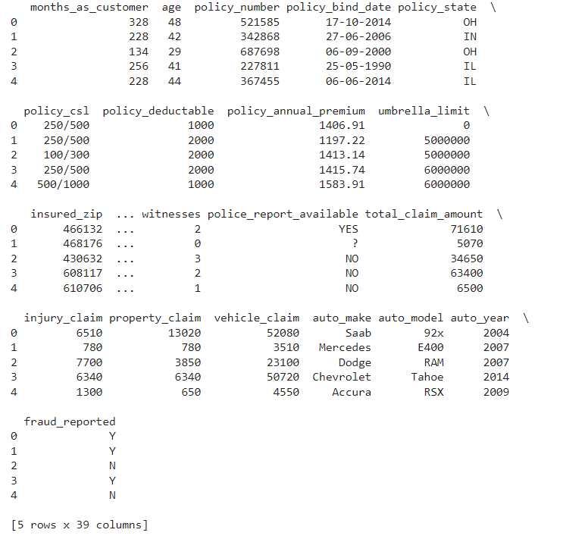

* Handle missing values and encode categorical variables:

# fill missing values

data = data.fillna('NA')

# encode categorical variables

le = LabelEncoder()

for column in data.select_dtypes(include=['object']).columns:

    data[column] = le.fit_transform(data[column])

# dataset after preprocessing

print(data.head())

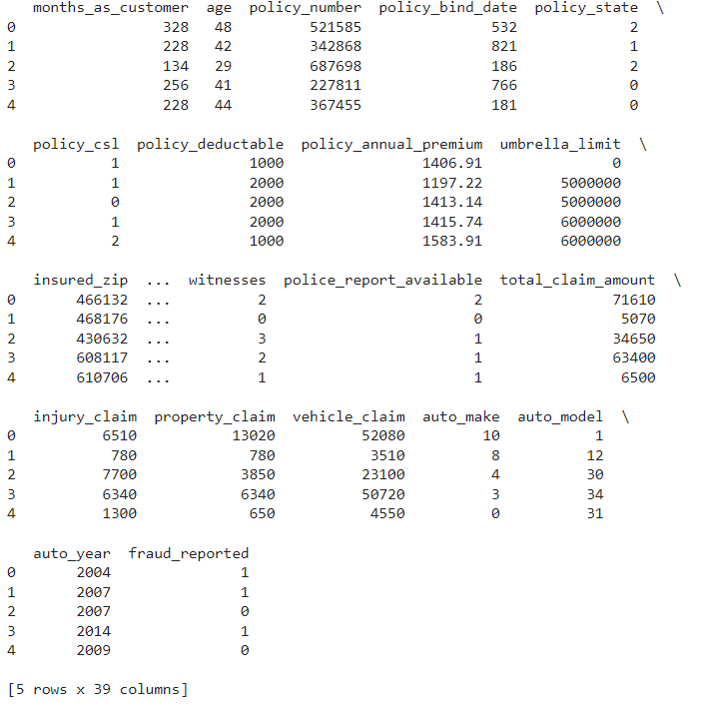

* Split the dataset into features and target variable:

# features and target variable

X = data.drop(columns=['fraud_reported'])

y = data['fraud_reported']

# Spliting the data to train and test sets

X_train, X_test, y_train, y_test = train_test_split(X, y, test_size=0.3, random_state=42)

**Model Training**

* Logistic Regression:

from sklearn.linear_model import LogisticRegression

from sklearn.metrics import accuracy_score, classification_report

# Train logistic regression model

lr_model = LogisticRegression(max_iter=1000)

lr_model.fit(X_train, y_train)

# Predict and evaluate

y_pred_lr = lr_model.predict(X_test)

lr_accuracy = accuracy_score(y_test, y_pred_lr)

print("Logistic Regression Accuracy:", lr_accuracy)

print("Classification Report:\n", classification_report(y_test, y_pred_lr))

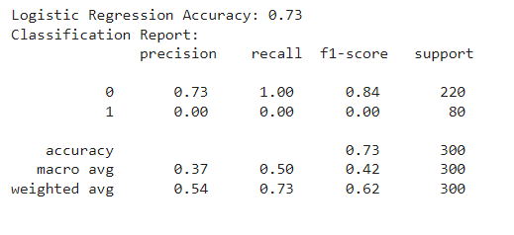

* Decision Tree:

from sklearn.tree import DecisionTreeClassifier

# Train decision tree model

dt_model = DecisionTreeClassifier(random_state=42)

dt_model.fit(X_train, y_train)

# Predict and evaluate

y_pred_dt = dt_model.predict(X_test)

dt_accuracy = accuracy_score(y_test, y_pred_dt)

print("Decision Tree Accuracy:", dt_accuracy)

print("Classification Report:\n", classification_report(y_test, y_pred_dt))

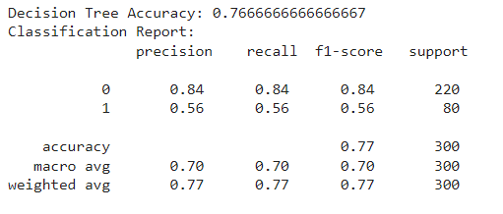

* Random Forest:

from sklearn.ensemble import RandomForestClassifier

# Train random forest model

rf_model = RandomForestClassifier(random_state=42)

rf_model.fit(X_train, y_train)

# Predict and evaluate

y_pred_rf = rf_model.predict(X_test)

rf_accuracy = accuracy_score(y_test, y_pred_rf)

print("Random Forest Accuracy:", rf_accuracy)

print("Classification Report:\n", classification_report(y_test, y_pred_rf))

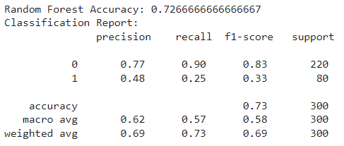

* Gradient Boosting:

from sklearn.ensemble import GradientBoostingClassifier

# Train gradient boosting model

gb_model = GradientBoostingClassifier(random_state=42)

gb_model.fit(X_train, y_train)

# Predict and evaluate

y_pred_gb = gb_model.predict(X_test)

gb_accuracy = accuracy_score(y_test, y_pred_gb)

print("Gradient Boosting Accuracy:", gb_accuracy)

print("Classification Report:\n", classification_report(y_test, y_pred_gb))

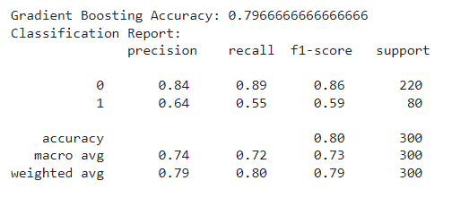

**Compare Models and Select the Best**

# Define models with accuracy scores

models = {

    "Logistic Regression": lr_accuracy,

    "Decision Tree": dt_accuracy,

    "Random Forest": rf_accuracy,

    "Gradient Boosting": gb_accuracy

}

# best model

best_model_name = max(models, key=models.get)

best_model_accuracy = models[best_model_name]

print(f"Best model: {best_model_name} with accuracy {best_model_accuracy}")

# best model's predictions

if best_model_name == "Logistic Regression":

    best_model = lr_model

elif best_model_name == "Decision Tree":

    best_model = dt_model

elif best_model_name == "Random Forest":

    best_model = rf_model

else:

    best_model = gb_model



**Exporting Data**

# predictions for the entire dataset using the best model

original_data['prediction'] = best_model.predict(data.drop(columns=['fraud_reported']))

# Export the data with predictions

original_data.to_csv('FraudPredictions.csv', index=False)

print("Data exported to FraudPredictions.csv")



Download the FraudPredictions.csv after the export is completed (It will be saved in the same directory where the dataset was)

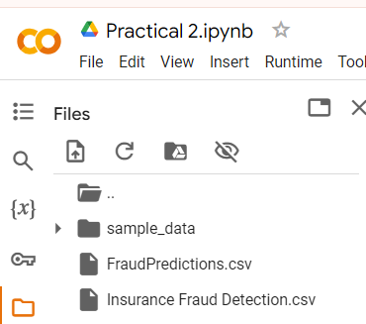

**[C] NEO4J VISUALIZATION ON PREDICTED DATA**

1. Click on the New panel and create a new project

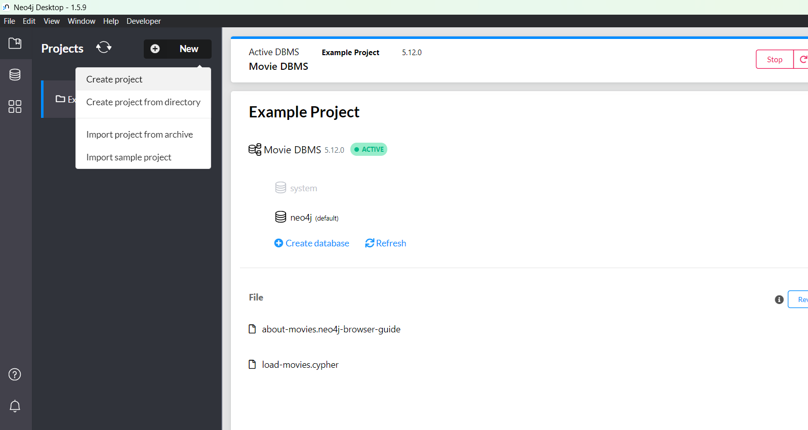

1. Rename the project to Practical 2



1. In the right side click on add panel and select local dbms

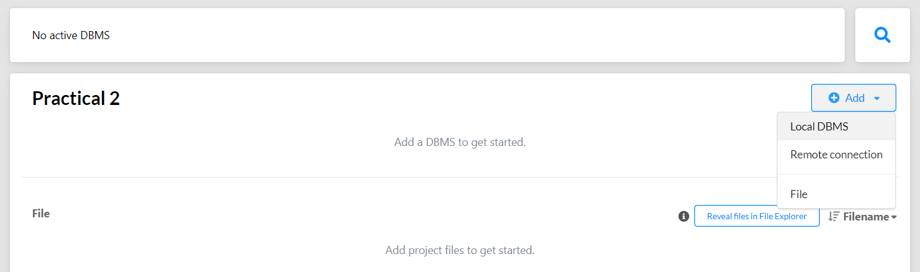

1. Set a password with eight characters long and click on create and wait till the dbms gets created

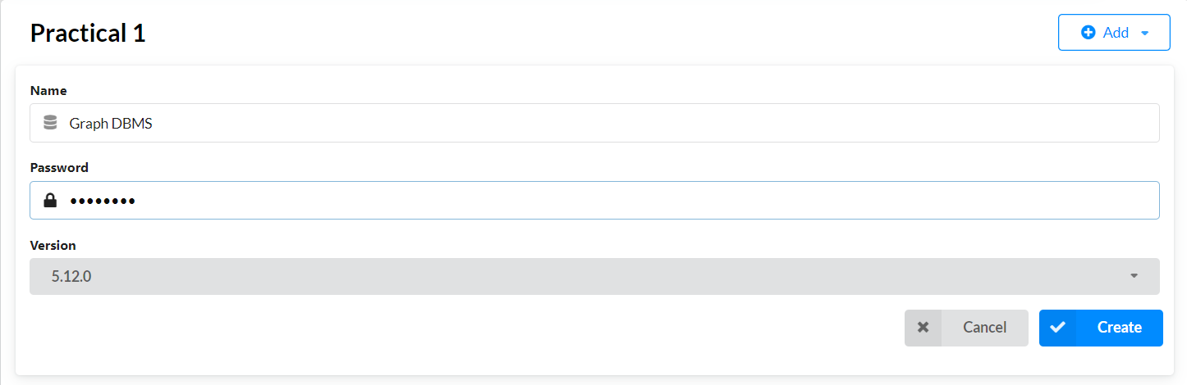

1. Now click on start button to strat the dbms

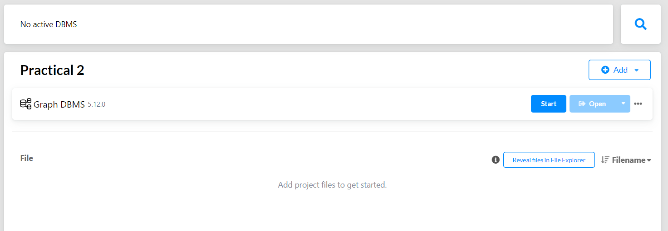

1. A terminal will open do not close it otherwise dbms will get stopped

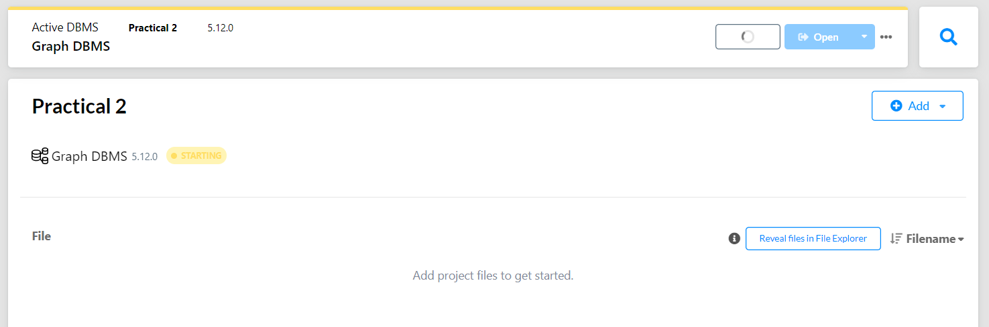

1. If the dbms gets started Click on open to start the neo4j browser on the localhost

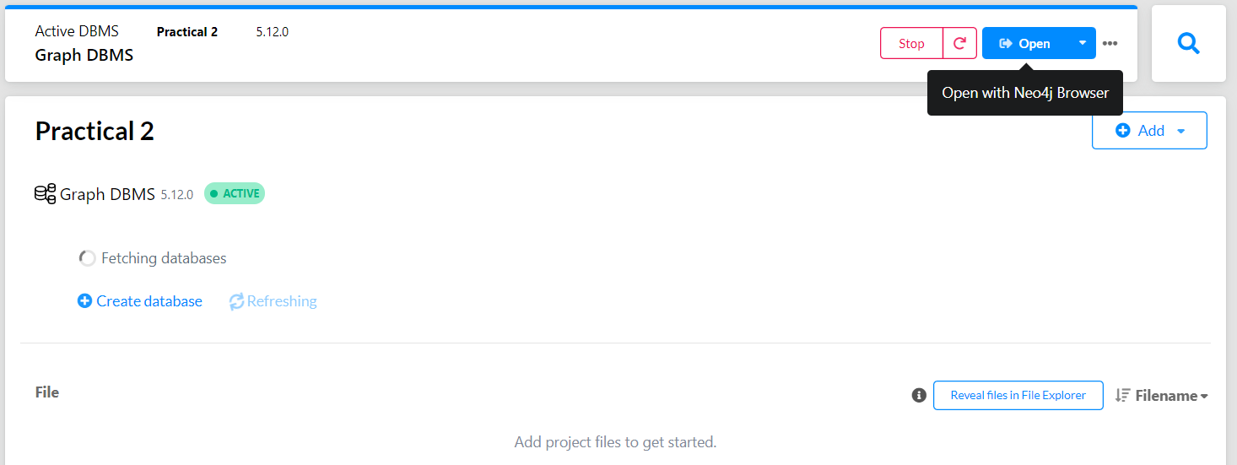

1. Neo4j Browser is opened if no issues detected

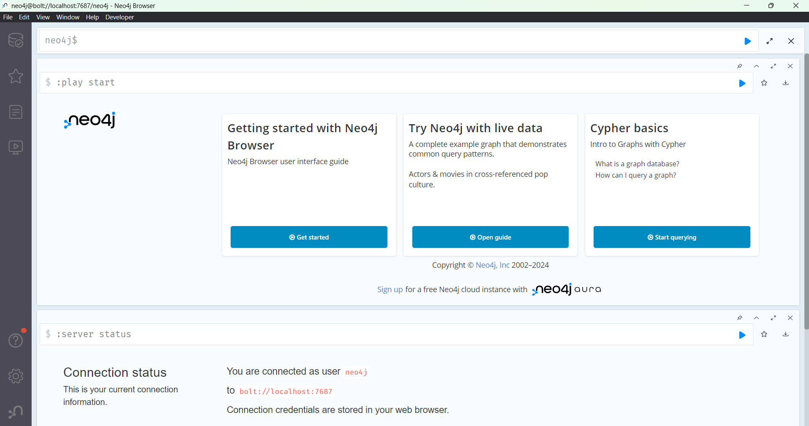

1. Clear all the cypher queries in the browser

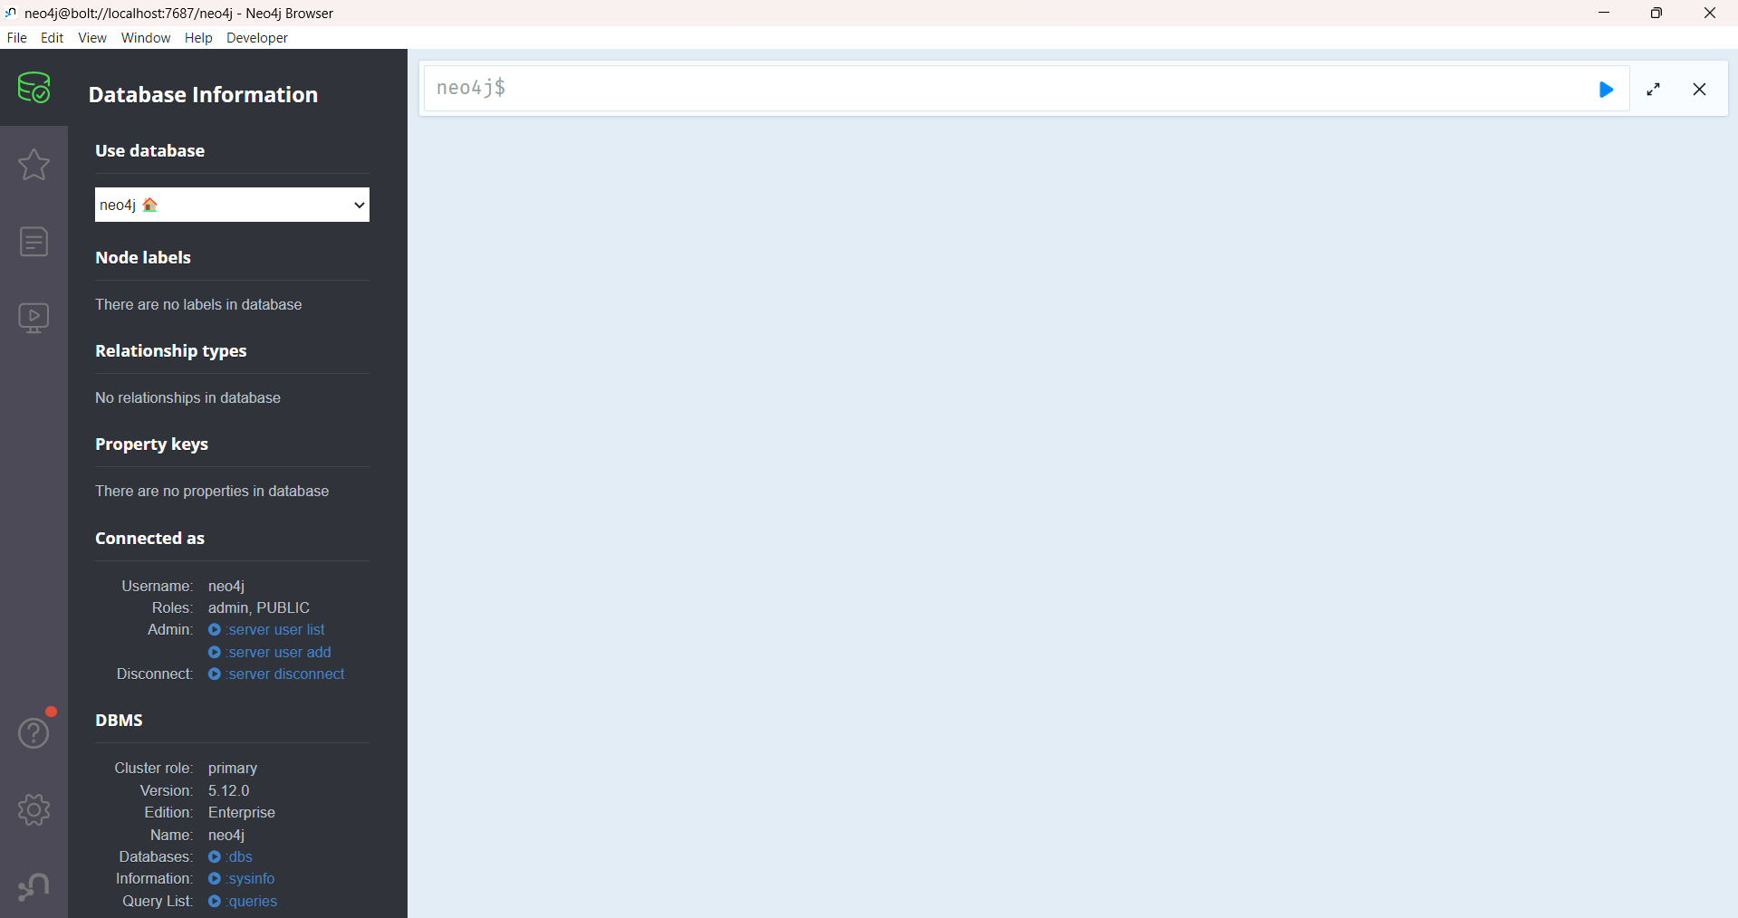

1. Now copy and paste your processed InsuranceFraudPredications.csv file into your project import directory (/Neo4j/relate-data/dbmss/dbms-projectid /import/)

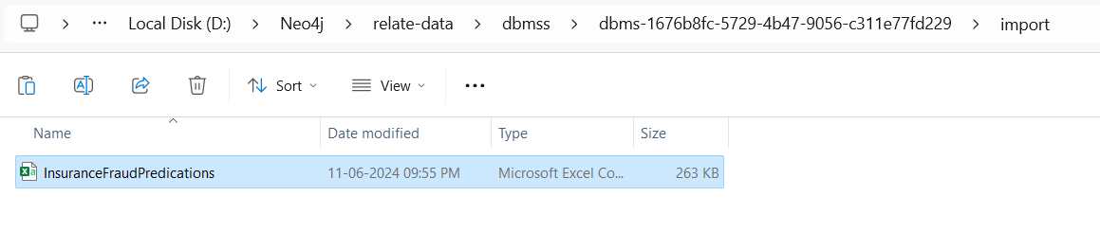

1. Get back to your neo4j browser and start your cypher query, first will import the dataset and assign the datatype of the columns
2. Load CSV and create Transaction nodes

LOAD CSV WITH HEADERS FROM 'file:///InsuranceFraudPredications.csv' AS row

CREATE (t:Transaction {

    months_as_customer: toInteger(row.months_as_customer),

    age: toInteger(row.age),

    policy_number: toInteger(row.policy_number),

    policy_bind_date: row.policy_bind_date,

    policy_state: row.policy_state,

    policy_csl: row.policy_csl,

    policy_deductable: toInteger(row.policy_deductable),

    policy_annual_premium: toFloat(row.policy_annual_premium),

    umbrella_limit: toInteger(row.umbrella_limit),

    insured_zip: toInteger(row.insured_zip),

    insured_sex: row.insured_sex,

    insured_education_level: row.insured_education_level,

    insured_occupation: row.insured_occupation,

    insured_hobbies: row.insured_hobbies,

    insured_relationship: row.insured_relationship,

    capital_gains: toInteger(row.capital_gains),

    capital_loss: toInteger(row.capital_loss),

    incident_date: row.incident_date,

    incident_type: row.incident_type,

    collision_type: row.collision_type,

    incident_severity: row.incident_severity,

    authorities_contacted: row.authorities_contacted,

    incident_state: row.incident_state,

    incident_city: row.incident_city,

    incident_location: row.incident_location,

    incident_hour_of_the_day: toInteger(row.incident_hour_of_the_day),

    number_of_vehicles_involved: toInteger(row.number_of_vehicles_involved),

    property_damage: row.property_damage,

    bodily_injuries: toInteger(row.bodily_injuries),

    witnesses: toInteger(row.witnesses),

    police_report_available: row.police_report_available,

    total_claim_amount: toFloat(row.total_claim_amount),

    injury_claim: toFloat(row.injury_claim),

    property_claim: toFloat(row.property_claim),

    vehicle_claim: toFloat(row.vehicle_claim),

    auto_make: row.auto_make,

    auto_model: row.auto_model,

    auto_year: toInteger(row.auto_year),

    fraud_reported: row.fraud_reported,

    prediction: row.prediction

});

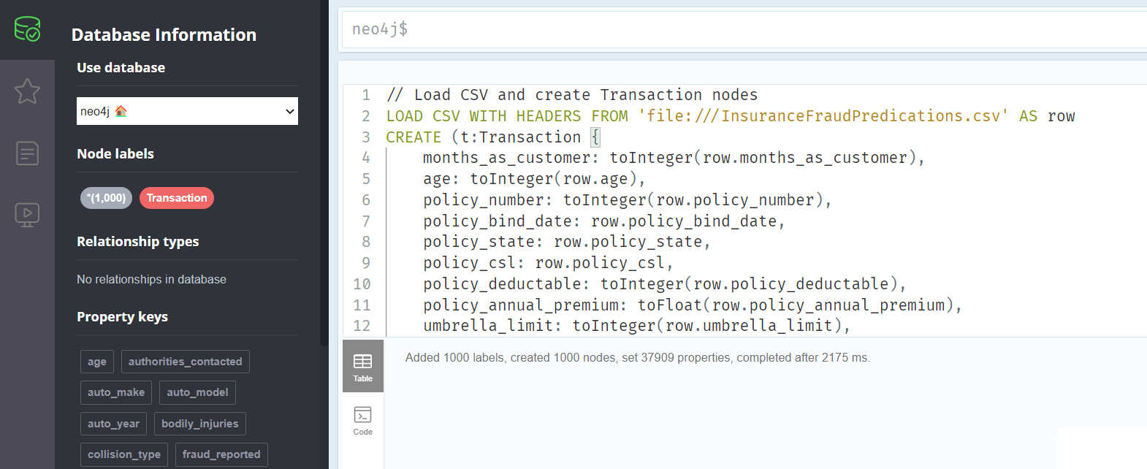

1. Create relationships based on specific policy state

MATCH (t1:Transaction)

WITH t1

MATCH (t2:Transaction)

WHERE t1.policy_state = t2.policy_state AND t1 <> t2

MERGE (t1)-[:SAME_POLICY_STATE]->(t2);

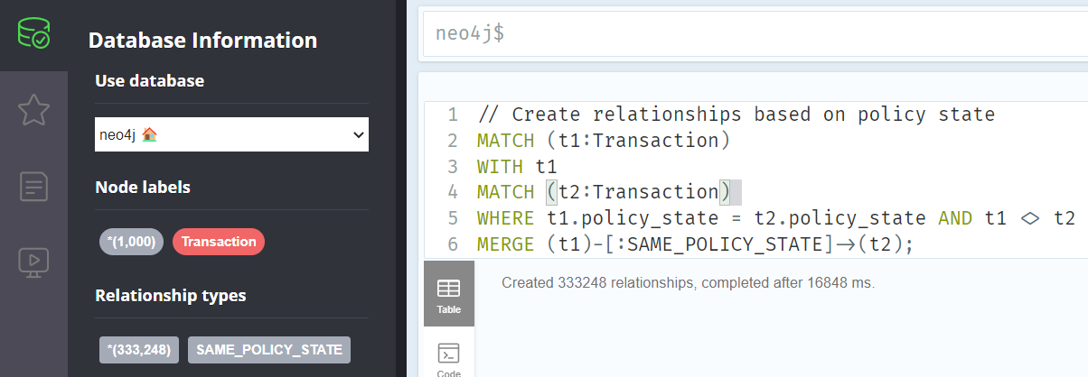

1. Create relationships based on specific incident type

MATCH (t1:Transaction)

WITH t1

MATCH (t2:Transaction)

WHERE t1.incident_type = t2.incident_type AND t1 <> t2

MERGE (t1)-[:SAME_INCIDENT_TYPE]->(t2);

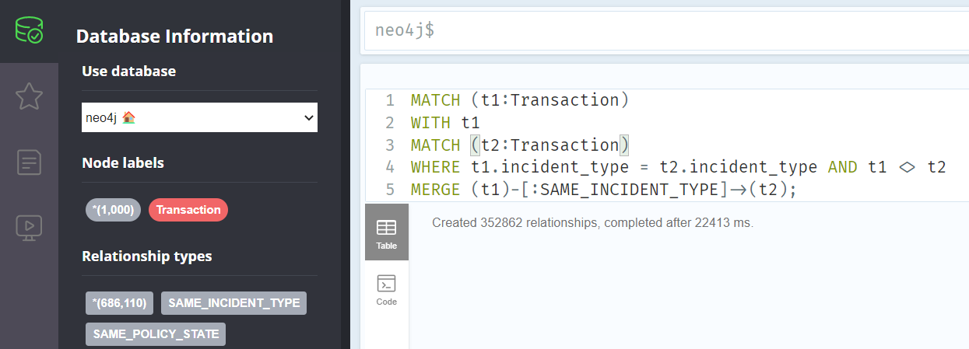

1. Create relationships based on specific auto make

MATCH (t1:Transaction)

WITH t1

MATCH (t2:Transaction)

WHERE t1.auto_make = t2.auto_make AND t1 <> t2

MERGE (t1)-[:SAME_AUTO_MAKE]->(t2);

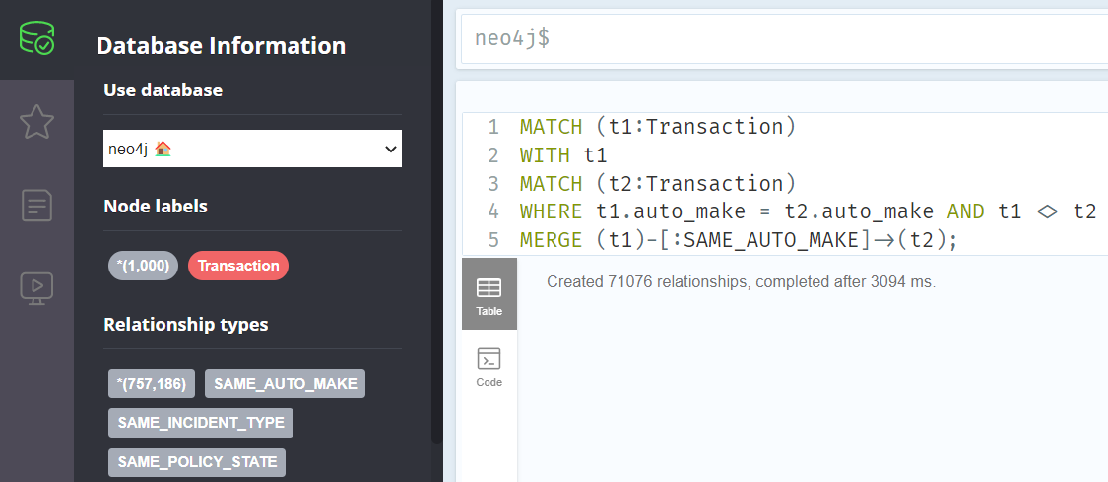

1. Create relationships for transactions reported as fraud

MATCH (t:Transaction)

WHERE t.fraud_reported = 'Y'

CREATE (t)-[:REPORTED_AS_FRAUD]->(r:Report {id: t.policy_number, date: t.incident_date, amount: t.total_claim_amount});

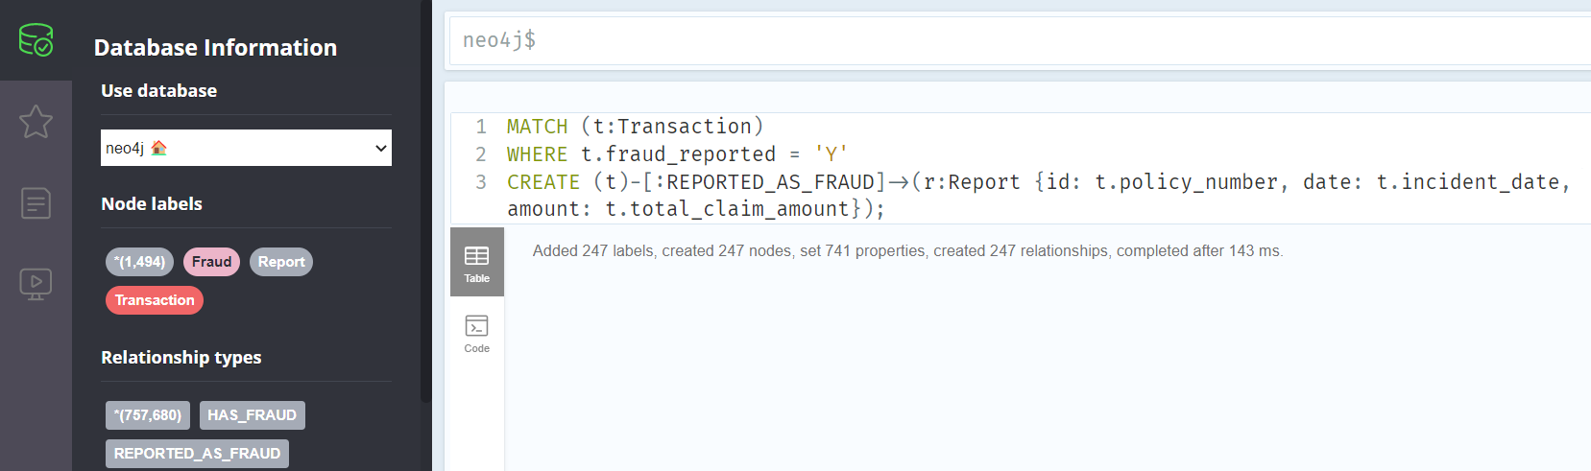

1. Create relationships for transactions predicted as fraud

MATCH (t:Transaction)

WHERE t.prediction = '1'

CREATE (t)-[:PREDICTED_AS_FRAUD]->(p:Prediction {id: t.policy_number, date: t.incident_date, amount: t.total_claim_amount});

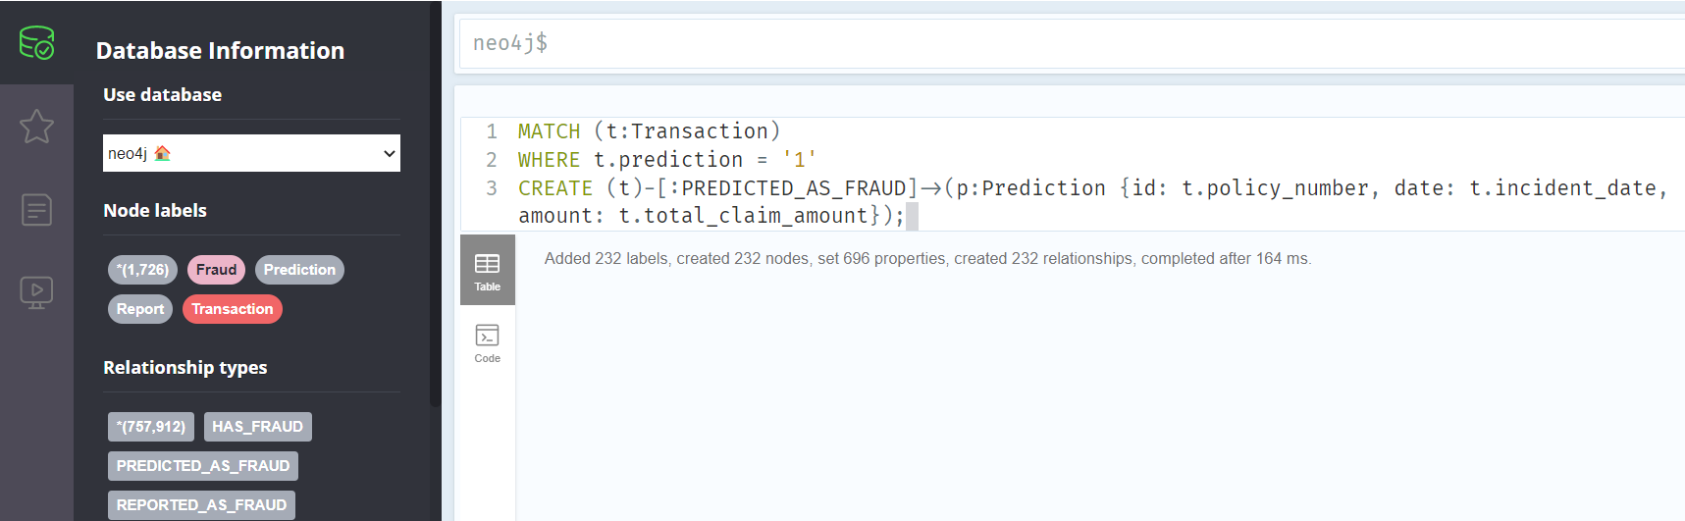

1. View all transactions that were reported as fraud

MATCH (t:Transaction)-[:REPORTED_AS_FRAUD]->(r:Report)

RETURN t, r LIMIT 4;

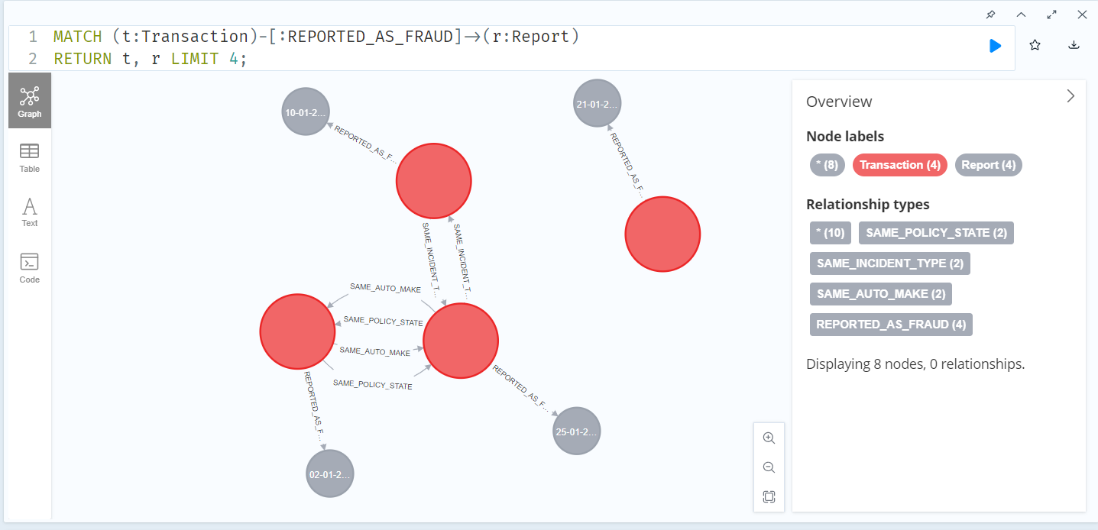

1. View all transactions that were predicted as fraud

MATCH (t:Transaction)-[:PREDICTED_AS_FRAUD]->(p:Prediction)

RETURN t, p LIMIT 4;

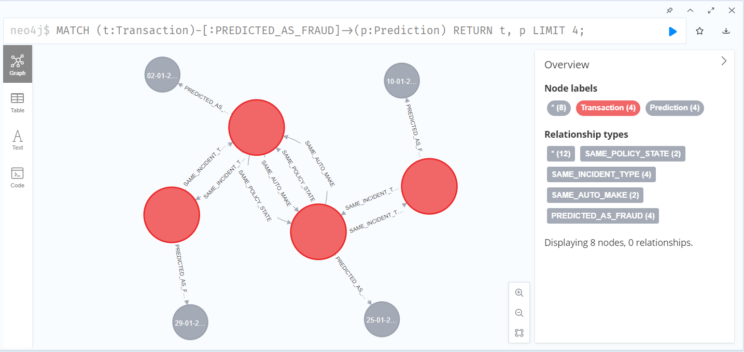

1. Compare transactions that are both predicted and reported as fraud (To see the details you can click on the nodes or its tie and see the values of it labels can be modified by clicking on it)

MATCH (t:Transaction)-[:PREDICTED_AS_FRAUD]->(p:Prediction), (t)-[:REPORTED_AS_FRAUD]->(r:Report)

RETURN t, p, r LIMIT 4;

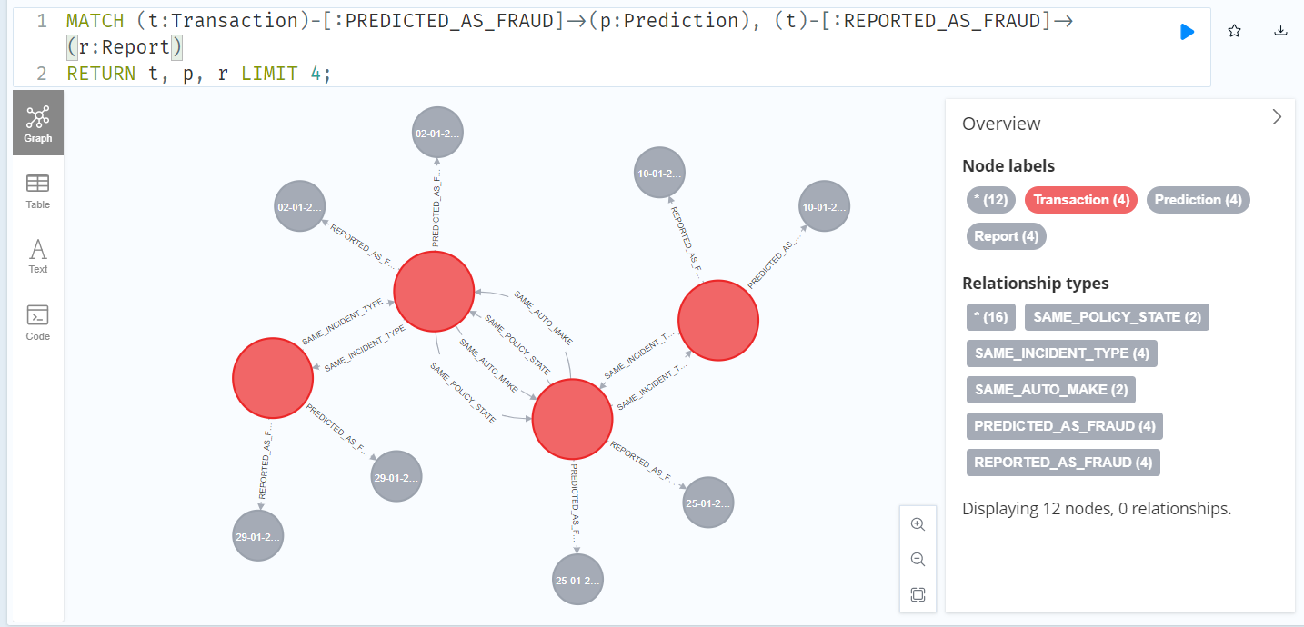

1. Filter by specific policy state (In this case “OH”)

MATCH (t:Transaction)-[:REPORTED_AS_FRAUD]->(r:Report)

WHERE t.policy_state = 'OH'

RETURN t, r LIMIT 4;

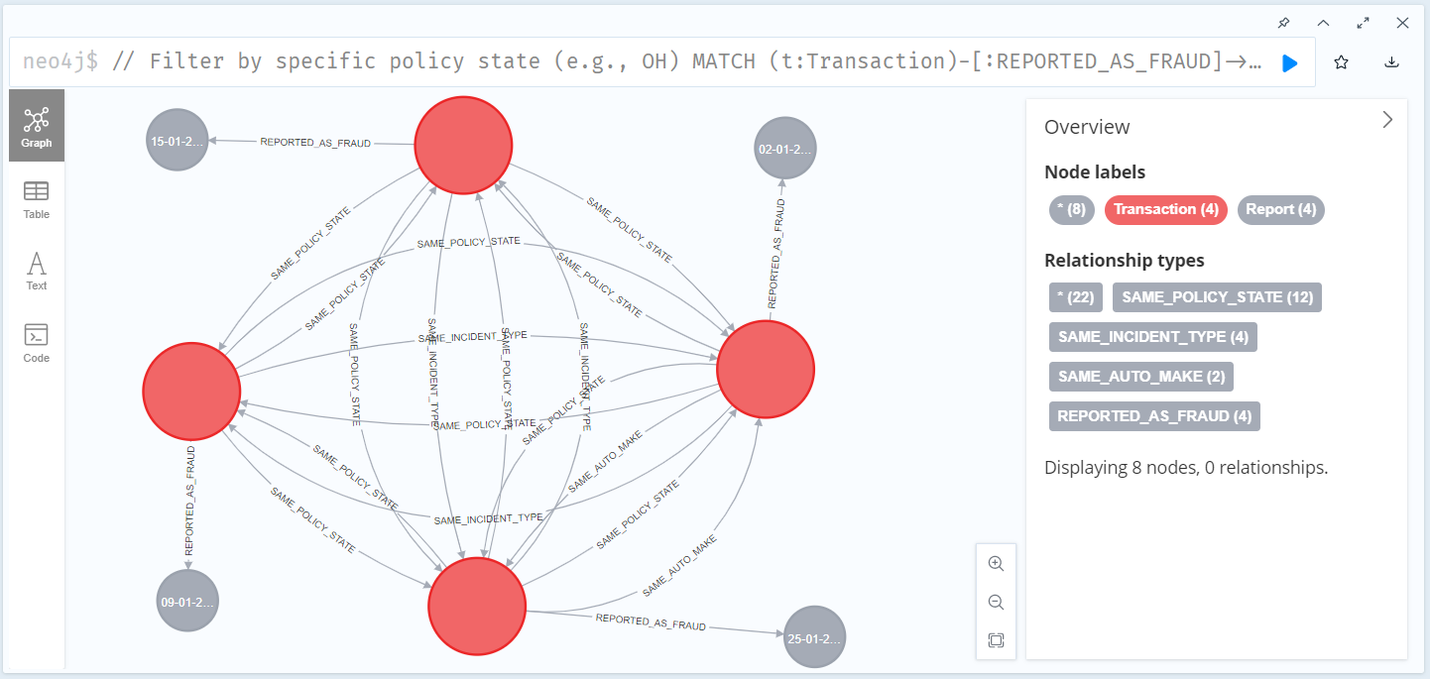

1. Filter by incident type (In this case “Vehicle Theft”)

MATCH (t:Transaction)-[:REPORTED_AS_FRAUD]->(r:Report)

WHERE t.incident_type = 'Vehicle Theft'

RETURN t, r LIMIT 3;

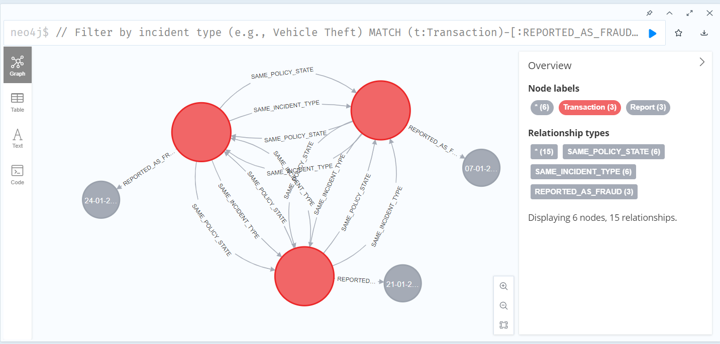

1. Filter by auto manufacturer (In this case “Mercedes”)

// Filter by auto make (e.g., Mercedes)

MATCH (t:Transaction)-[:REPORTED_AS_FRAUD]->(r:Report)

WHERE t.auto_make = 'Mercedes'

RETURN t, r LIMIT 3;

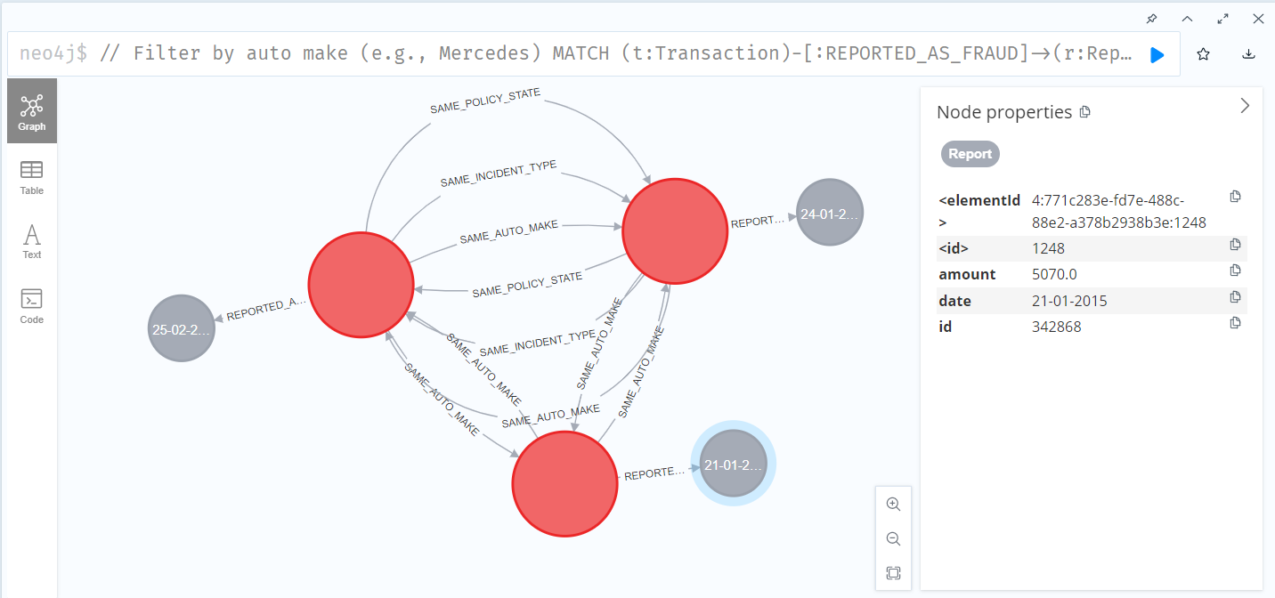

1. You can see the details by clicking on nodes and also can modify according to your need by clicking on the label